Deployment Package
Software Requirements Analysis
Basic Profile

Notes:
This document is the intellectual propriety of its author’s organization. However, information contained in this document is free of use. The distribution of all or parts of this document is authorized for non commercial use as long as the following legal notice is mentioned:

© Centre d’Excellence en Technologies de l’Information et de la Communication and École de Technologie Supérieure

Commercial use of this document is strictly forbidden. This document is distributed in order to enhance exchange of technical and scientific information.
This material is furnished on an “as-is” basis. The author(s) make(s) no warranties of any kind, either expressed or implied, as to any matter including, but not limited to, warranty of fitness for purpose or merchantability, exclusivity, or results obtained from use of the material.
The processes described in this Deployment Package are not intended to preclude or discourage the use of additional processes that Very Small Enterprises may find useful.

Authors | S. ALEXANDRE, – Centre d’Excellence en Technologies de l’Information et de la Communication (CETIC), (Belgium)  C. Y. LAPORTE, École de Technologie Supérieure (ETS), (Canada)
Editors | C. Y. LAPORTE, École de Technologie Supérieure  ANA VAZQUEZ – 5th level, (México)
Creation date | 7 August 2007
Status | Draft
Version | 1.2

Versions

Date | Version | Auteur | Modification
07/08/2007 | 0.1 | S. ALEXANDRE | Document creation
20/08/2007 | 0.2 | C.Y. LAPORTE | Comments on document structure
1/10/2007 | 0.3 | S. ALEXANDRE | Implementation of comment and finalization of V1.0
1/10/2007 | 0.4 | S. ALEXANDRE | Comments after review
8/10/2007 | 0.5 | S. ALEXANDRE | Update and completion of section 3.1
14/10/2007 | 0.6 | S. ALEXANDRE – C.Y. LAPORTE | Update and revision of section 3.1
19/10/2007 | 0.7 | S. ALEXANDRE | Update of section 3.1 and 3.2
29/10/2007 | 0.8 | S. ALEXANDRE | Replacement of ‘practice’ by ‘activity’ to comply with OGF SPEM terminology.
2/11/2007 | 0.9 | S. ALEXANDRE | Alignment of the content with ISO12207:2008.
27/11/2007 | 0.10 | S. ALEXANDRE | Update of graphical representation of steps.
1/12/2007 | 1.0 | S. ALEXANDRE | Final version – ready for final review
21/01/2008 | 1.1 | S. ALEXANDRE | Update of coverage matrix
7/07/2009 | 1.2 | C.Y. LAPORTE | Modification to the copyright clause definitions and acronyms, and implementation of new DP template.

Abbreviations/Acronyms

Abre./Acro. | Definition
DP | Deployment Package - a set of artefacts developed to facilitate the implementation of a set of practices, of the selected framework, in a Very Small Entity.
VSE | Very Small Entity – an enterprise, organization, department or project having up to 25 people.
VSEs | Very Small Entities

Table of Contents
1. Technical Description 4
Purpose of this document 4
Why Requirements Management is Important ? 4
Main Causes of Success 5
2. Definitions 7
Generic Terms 7
Specific Terms 7
3. Relationships with ISO/IEC 29110 9
4. Description of Processes, Activities, Tasks, Steps, Roles and Products 11
Tasks 11
Requirements identification 11
Requirements refinement and analysis 12
Requirements verification & validation 13
Requirements change management 14
Roles 16
Artefacts 16
5. Template 17
6. Example of Lifecycle 22
Example 1 of Requirement Practices Lifecycle 22
Example 2 of Requirement Practices Lifecycle 23
7. Checklist 24
Requirement checklist 24
8. Tool 25
Traceability Tool 25
9. References to Other Standards and Models 27
ISO 9001 Reference Matrix 27
ISO/IEC 12207 Reference Matrix 28
CMMI Reference Matrix 28
10. References 29
11. Evaluation Form 30

1. Technical Description

Purpose of this document
This Deployment Package (DP) supports the Basic Profile as defined in ISO/IEC 29110 Part 5-1: Management and Engineering Guide. A DP is a set of artefacts developed to facilitate the implementation of a set of practices in a Very Small Entity (VSE). A DP is not a process reference model (i.e. it is not prescriptive). The elements of a typical DP are: description of processes, activities, tasks, roles and products, template, checklist, example, reference and reference to standards and models, and tools.
In IT projects, it is critical to define as unambiguously as possible the customer requirements to ensure a common comprehension of requirements between the stakeholders, and to guarantee that requirements evolution is handled as part of the project.
Requirements analysis process includes the production and the maintenance of Software Requirements Specifications on the basis of customer demands and changes in these demands. Software Requirements Specifications will then constitute the basis for cost estimate, planning, implementation and tracking of activities throughout the project.
Requirements Management is one of the principal parameters for process stabilization and successful repeatability.

The content of this document is entirely informative.

This document has been produced by CETIC (Centre of Excellence in Information and Communication Technologies – www.cetic.be ), CRPHT (Public Research Centre Henri Tudor’s – www.tudor.lu ) and ETS (Ecole de Technologie Supérieure - www.etsmtl.ca ) beyond their official participation to ISO JTC1/SC7/WG24.

Why Requirements Management is Important ?
Several studies clearly underlined the importance of requirement management in software engineering. Among these studies, the Chaos Report published by the Standish Group (www.standishgroup.com/ ) from 1994 the Standish Group analyzed thousands of IT projects all over the world.
The Standish Group categorized IT projects into three resolution categories:
- Successful: The project is completed on time and on budget, with all features and functions originally specified.
- Challenged: The project is completed and operational, but over-budget, over the time estimate, and with fewer features and functions than initially specified.
- Failed: The project is cancelled before completion or is never implemented.

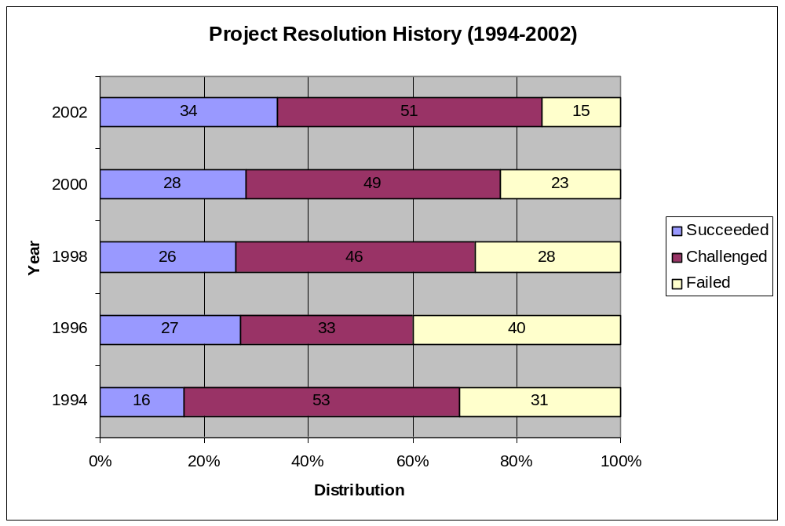
Figure 1 Project resolution history

Main Causes of Success
According to the Standish Group, the main causes of SUCCESS are:
- User Involvement
- Executive Support
- Clear Business Objectives
- Experienced Project Manager
- Small Milestones
- Firms Basic Requirements
Standish Group experts underlined the importance of user involvement and the good management and analysis of their requirements.

Figure 2 representing data from a real company shows that close to 50% of the defects are produced during the requirements phase.
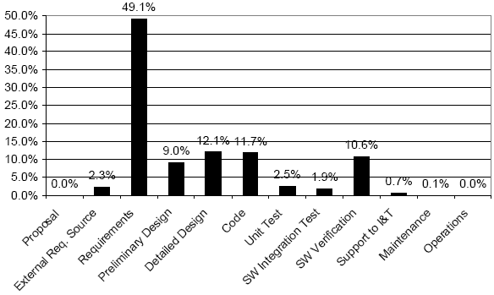

Figure 2 Origins of software defects

2. Definitions

In this section, the reader will find two sets of definitions. The first set defines the terms used in all Deployment Packages, i.e. generic terms. The second set of terms used in this Deployment package, i.e. specific terms.

Generic Terms
Process: set of interrelated or interacting activities which transform inputs into outputs [ISO/IEC 12207].

Activity: a set of cohesive tasks of a process [ISO/IEC 12207].

Task: required, recommended, or permissible action, intended to contribute to the achievement of one or more outcomes of a process [ISO/IEC 12207].

Sub-Task: When a task is complex, it is divided into sub-tasks.

Step: In a deployment package, a task is decomposed in a sequence of steps.

Role: a defined function to be performed by a project team member, such as testing, filing, inspecting, coding. [ISO/IEC 24765]

Product: piece of information or deliverable that can be produced (not mandatory) by one or several tasks. (e. g. design document, source code).

Artefact: information, which is not listed in ISO/IEC 29110 Part 5, but can help a VSE during the execution of a project.

Specific Terms
Requirement: 1. a statement that identifies what a product or process must accomplish to produce required behaviour and/or results. IEEE 1220-2005 IEEE Standard for the Application and Management of the Systems Engineering Process. 3.1.16. 2. a system or software requirement that specifies a function that a system/software system or system/software component must be capable of performing. ISO/IEC 24765, Systems and Software Engineering Vocabulary. 3. a requirement that specifies a function that a system or system component must be able to perform. [ISO/IEC24765]

Requirements analysis: The process of studying user needs to arrive at a definition of system, hardware, or software requirements. [ISO/IEC 24765]

Requirements document: a document containing any combination of recommendations, requirements or regulations to be met by a software package. [ISO/IEC 24765]

Requirements phase: the period of time in the software life cycle during which the requirements for a software product are defined and documented. [ISO/IEC 24765]

Software Requirements Specifications: The SRS is a specification for a particular software product, program, or set of programs that performs certain functions in a specific environment. The SRS may be written by one or more representatives of the supplier, one or more representatives of the customer, or by both. [IEEE830-98]
The SRS document contains both functional and non functional requirements.
The SRS can be materialized in a word document but it can also be managed in a database or in an Excel file.

Non Functional Requirement: a software requirement that describes not what the software will do but how the software will do it. ISO/IEC 24765, Systems and Software Engineering Vocabulary. Syn. design constraints, non-functional requirement. See also: functional requirement. NOTE for example, software performance requirements, software external interface requirements, software design constraints, and software quality attributes. Non functional requirements are sometimes difficult to test, so they are usually evaluated subjectively. [ISO/IEC24765]

Prototype: an experimental model, either functional or non functional, of the system or part of the system. IEEE 1233, 1998 Edition (R2002) IEEE Guide for Developing System Requirements Specifications. 3.12. 2. a preliminary type, form, or instance of a system that serves as a model for later stages or for the final, complete version of the system. ISO/IEC 24765, Systems and Software Engineering Vocabulary. 3. model or preliminary implementation of a piece of software suitable for the evaluation of system design, performance or production potential, or for the better understanding of the software requirements. ISO/IEC 15910:1999 Information technology -- Software user documentation process. 4.41. [ISO/IEC24765]

Traceable. 1. having components whose origin can be determined. [ISO/IEC24765]

Traceability matrix. 1. a matrix that records the relationship between two or more products of the development process. [ISO/IEC24765]

3. Relationships with ISO/IEC 29110
This deployment package covers the activities related to requirements analysis of the ISO Technical Report ISO/IEC 29110 Part 5-1 for Very Small Entities (VSEs) – Basic Profile [ISO/IEC29110].

In this section, the reader will find a list of applicable Project Management (PM) and Software Implementation (SI) process, activities, tasks and roles that are directly related to this topic.
- Process: Software Implementation
- Activity: SI.2 Software requirements analysis
- Tasks and Roles:

Task List | Role
SI.2.1 Assign tasks to the Work Team members in accordance with their role, based on the current Project Plan. | TL, WT
SI.2.2 Document or update the Requirements Specification.  Identify and consult information sources (customer, users, previous systems, documents, etc.) in order to get new requirements.  Analyze the identified requirements to determinate the scope and feasibility.  Generate or update the Requirements Specification. | AN, CUS
SI.2.3 Verification of the Requirements Specification.  Verify the correctness and testability of the Requirements Specification and its consistency with the Product Description. Additionally, review that requirements are complete, unambiguous and not contradictory. The results found are documented in a Verification Results and corrections are made until the document is approved by AN. If significant changes were needed, initiate a Change Request. | AN
SI.2.4 Validation of the Requirements Specification  Validate that Requirements Specification satisfies needs and agreed upon expectations, including the user interface usability. The results found are documented in a Validation Results and corrections are made until the document is approved by CUS. | CUS, AN
SI.2.5 Document the preliminary version of the Software User Documentation or update the present manual.  (optional) | AN
SI.2.6 Verification of the Software User Documentation  Verify consistency of the Software User Documentation with the Requirement Specification. .The results found are documented in a Verification Results and corrections are made until the document is approved by AN. If significant changes were needed, initiate a Change Request. (optional) | AN
SI.2.7 Incorporate the Requirements Specification, and *Software User Documentation to the Software Configuration in the baseline. *(optional) | TL

4. Description of Processes, Activities, Tasks, Steps, Roles and Products

Process: Software Implementation

Activity: SI.2 Software requirements analysis

Task List | Role
SI.2.1 Assign tasks to the Work Team members in accordance with their role, based on the current Project Plan. | TL, WT
SI.2.2 Document or update the Requirements Specification. | AN, CUS
SI.2.3 Verification of the Requirements Specification. | AN
SI.2.4 Validation of the Requirements Specification | CUS, AN
SI.2.5 Document the preliminary version of the Software User Documentation or update the present manual. (optional) | AN
SI.2.6 Verification of the Software User Documentation | AN
SI.2.7 Incorporate the Requirements Specification, and *Software User Documentation to the Software Configuration in the baseline. *(optional) | TL

Tasks

Requirements identification

Objectives: | The objective of this activity is to clearly define the scope of the project and identify the key requirements of the system.
Rationale: | It is important to clearly define the project scope (boundaries) and to identify key functionalities of the future system with the customer to avoid problems like forgotten key functionalities or requirements creep.
Roles: | Project Manager
Roles: | Analyst
Artefacts: | Use Cases – scenarios
Artefacts: | Requirements Document
Steps: | - Collect information about the application domain (e.g. finance, medical)
Steps: | - Identify project’s scope
Steps: | - Identify and capture requirements
Steps: | - Structure and prioritize requirements
Step Description: | Step 1. Collect information about the domain:  During this Step, analyst captures the key concepts of the business domain of the customer. The customer assists the analyst by giving him all the information (existing documentation or explanation) that will facilitate this understanding.  Key concepts are listed in a glossary section in the Software Requirements Specification Document outline document.  Step 2. Identify project’s scope  Software analyst, helped by the person in charge of the contractual aspects of the project (sales manager) clearly identifies main functionalities that are included in the project scope.  Tips: Identifying functionalities that are OUT of scope is also very valuable to clarify differences of understanding with your customers.  Step 3. Identify and capture requirements  Having in mind key concepts related to the customer business domain, analyst can start requirements identification. None of the situations in IT projects are identical. In some cases, most of the requirements are already identified in a document (call for tender in case of fixed priced projects). However, in most of the cases, key requirements are just (orally) mentioned by the customer.  Analyst must identify and list the key requirements of the system to be built. During this Step, analyst should not start detailing identified requirements. The main goal is to gain a comprehensive view of the system requirements.  Step 4. Structure and prioritize requirements:  Using requirements identified in the previous Step, the analyst has to organise and structure identified requirements accordingly (e.g. by business processes or by system functions).  A priority must be identified by the customer for system key functionalities. Priorities can be stated like  - ‘High’ – a functionality that shall be implemented  - ‘Medium’ - a functionality that should be implemented  - ‘Low’ - a functionality that could be implemented  The output of this Step is a list of requirements that are organized in the Requirements Document.

Requirements refinement and analysis
Objectives: | The objective of this Step is to detail and analyse all the requirements identified.
Rationale: | It is important to go through identified requirements in order to detect requirements that seem easy to implement but hiding a business complexity that will cause problems in the project.
Roles: | Analyst
Roles: | Customer
Roles: | Developer
Artefacts: | Use Cases – scenarios
Artefacts: | Requirements Document
Artefacts: | Software prototype
Steps: | - Detail requirements
Steps: | - Produce a prototype
Step Description: | Step 1. Detail requirements:  The analyst goes through a set of identified requirements and performs a more detailed analysis.  Business complexity can be implicit for some requirements. This must be clarified at this point before any implementation.  The analyst will interact with customer representatives in order to clarify ergonomic question, if relevant (e.g. if a Graphical User Interface must be developed).  This Steps results in a new version of the Software Requirements Specification Document.  Step 2. Produce a prototype  Producing a prototype can facilitate requirement understanding from all project participants (i.e. customer side and development team side). A prototype may only implement some of the functionalities.

Requirements verification & validation
Objectives: | Verify requirements and obtain validation from the customer or his representative.
Rationale: | In order to avoid constant fundamental changes in the requirements, it is important to ask for the requirement validation from the customer.
Roles: | Analyst
Roles: | Customer
Roles: | Project Manager
Roles: | Developer
Artefacts: | Requirements Document
Artefacts: | Software prototype
Steps: | - Clarify fuzzy requirements (verification)
Steps: | - Review software requirements specification
Steps: | - Validate requirements
Description: | Step 1. Clarify fuzzy requirements:  Review requirements in order to detect requirements that are not clear enough (customer or software developer could understand it differently).  Theses criteria can be used to perform this review:  - Clear (avoid ambiguous requirements)  - Unique (i.e. avoid two requirements stating the same thing)  - Feasible (according project allocated resources)  - Testable  Step 2. Review software requirements specification:  During this Step requirements are roughly reviewed with the customer in order to be sure that requirements are:  - Complete  - Correct  Tips: This Step can be iteratively done by reviewing a given subset of requirements. Software engineers must be involved in order to identify technical dependencies between requirements (i.e. Requirement A must be implemented before requirement B due to implementation reason.)  Step 3. Validate requirements:  Obtain from your customer an approval of the requirements (or of a given subset if you are using an iterative lifecycle).

Requirements change management
Objectives: | To manage requirements change according with a process agreed upon with the customer.
Rationale: | Requirements change is a permanent feature of most of the IT projects. Change management must be planned and agreed upon with the customer on the project.
Roles: | Analyst
Roles: | Project Manager
Roles: | Customer
Artefacts: | Requirements Document
Steps: | - Track changes to requirements
Steps: | - Analyze impact of changes
Steps: | - Identify changes that are out of the project scope
Steps: | - Prioritize changes
Description: | Step 1. Track changes to requirements  This Step aims to collect and manage in a central repository (can be an excel sheet or any other database) any changes that are formulated against requirements.  This encompasses changes to existing requirements but also new or deleted requirements.  Step 2. Analyze impact of changes  Identify the impact on the project schedule and cost of each of the requested changes.  Step 3. Identify changes that are out of the project scope  Analyst helped by the person in charge of the contractual aspects of the project (sales manager) identifies changes that are out of the project scope. Changes that could impact the project budget should be discussed with the customer.  Step 4. Prioritize changes  During this Step, the project manager must obtain from the customer a prioritization of the identified changes in order to adapt the project planning.

Roles

Role | Definition
Analyst | Person in charge within the development team to gather, analyze and manage the requirements related to the software to be developed.
Customer | Person in charge within the customer side to transfer and validate requirements to the development team. It can be the customer or any representative.
Developer | Person in charge of the development of the software.
Project Manager | Person in charge of managing the project (cost, schedule, tasks, contract,…)
Table 1 Definitions of Roles

Artefacts

Artefacts | Definition
Use Cases – scenarios | Description of a sequence of interactions between the user and the future systems. Uses cases can be written as prescribed by UML but can also be text scenarios.
Requirements Document | Document in which all identified requirements are centralized. See Software Requirements Specification definition in section .
Software prototype | Working piece of software produced during the early phases in order to demonstrate/validate a functionality of a system.
Table 2 Definitions of Artefacts

5. Template
The templates provided with this deployment package should be customized for your project.
SRS Template Table of Content –Basic List of Requirements

To be used in an Excel sheet structured, for example, as:
ID | Requirement | Description | Priority

SRS Template Table of Content –Adapted from IEEE 830

1. Introduction
1.1 Purpose
1.2 Document conventions
1.3 Intended audience
1.4 Additional information
1.5 Contact information/SRS team members
1.6 References

2. Overall Description
2.1 Product perspective
2.2 Product functions
2.3 User classes and characteristics
2.4 Operating environment
2.5 User environment
2.6 Design/implementation constraints
2.7 Assumptions and dependencies

3. External Interface Requirements
3.1 User interfaces
3.2 Hardware interfaces
3.3 Software interfaces
3.4 Communication protocols and interfaces

4. System Features
4.1 System feature A
4.1.1 Description and priority
4.1.2 Action/result
4.1.3 Functional requirements
4.2 System feature B

5. Other Non functional Requirements
5.1 Performance requirements
5.2 Safety requirements
5.3 Security requirements
5.4 Software quality attributes
5.5 Project documentation
5.6 User documentation

6. Other Requirements
Appendix A: Terminology/Glossary/Definitions list
Appendix B: To be determined

SRS Template Table of Content -Construx
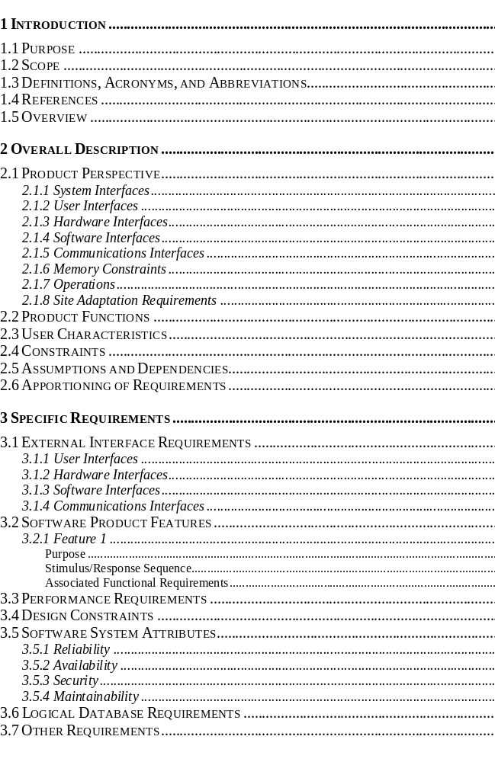

SRS Template Table of Content – Volere
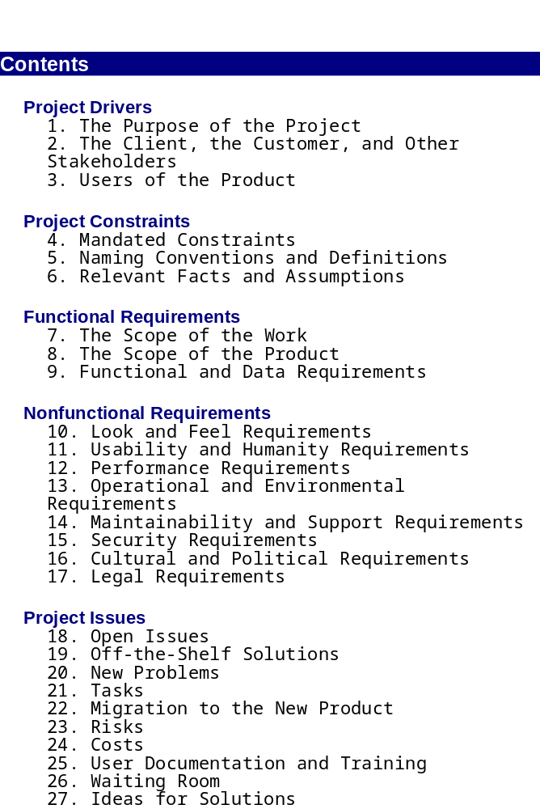

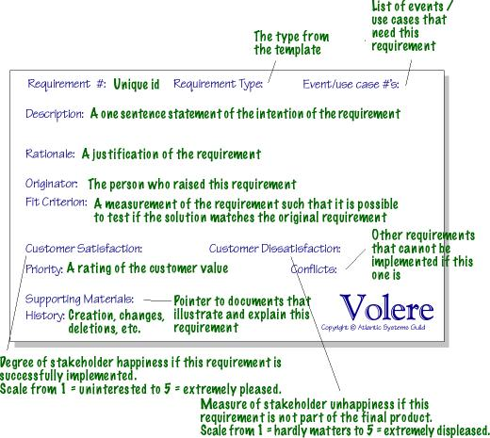SRS Template Table of Content – Volere Requirement Shell

6. Example of Lifecycle
Disclaimer: This section provides some graphical representation of example of requirement practices lifecycle. These examples are provided to help the reader to implement his own requirement lifecycle fitting his IT project’s context and constraints.

Example 1 of Requirement Practices Lifecycle

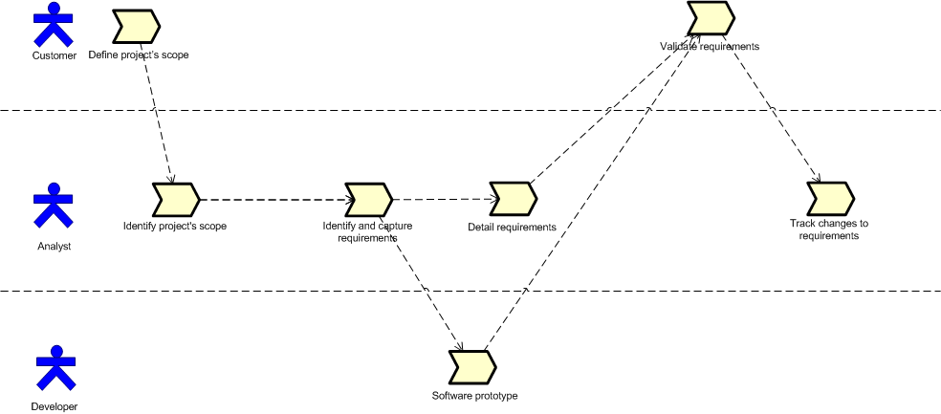
Figure 3 Example 1 of Requirement Practices Lifecycle

Example 2 of Requirement Practices Lifecycle

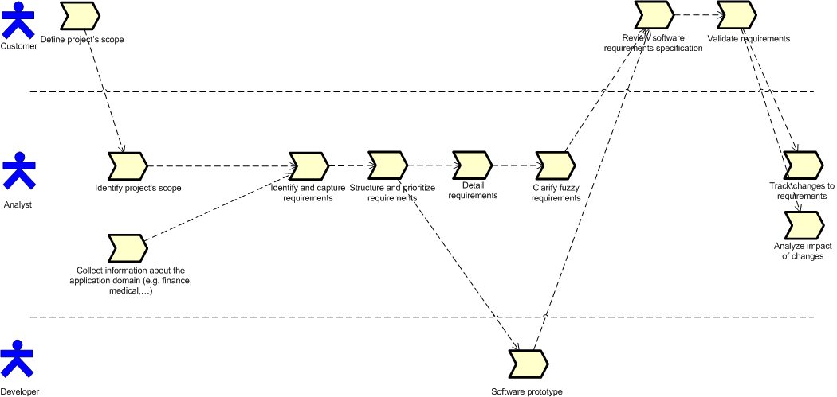
Figure 4 Example 2 of Requirement Practices Lifecycle

7. Checklist

Requirement checklist
This Requirement checklist is based on [Constr07]

RS 1 Testable | All requirements are verifiable (objectively)
RS 2 Complete | Are the requirements complete?
RS 3 Traceable | All requirements must be traceable to a systems specification, contractual/proposal clause.
RS 4 Correct | Requirements must be correct (i.e. reflect exactly customer’s requirements)
RS 5 Unique | Requirements must be stated only once
RS 6 Elementary | Requirements must be broken into their most elementary form
RS 8 High Level | Requirement must be stated in terms of final need, not perceived means (solutions)
RS 9 Quality | Quality attributes have been defined.
RS 10 Unambiguous
RS 11 Hardware | Hardware environment is completely defined.
RS 12 Solid | Requirements are a solid base for design

8. Tool

Traceability Tool
- Objectives:
  - To maintain the linkage from the source of each requirement through its decomposition to implementation and test (verification).
  - To ensure that all requirements are addressed and that only what is required is developed.
  - Useful when conducting impact assessments of requirements, design or other configured item changes.

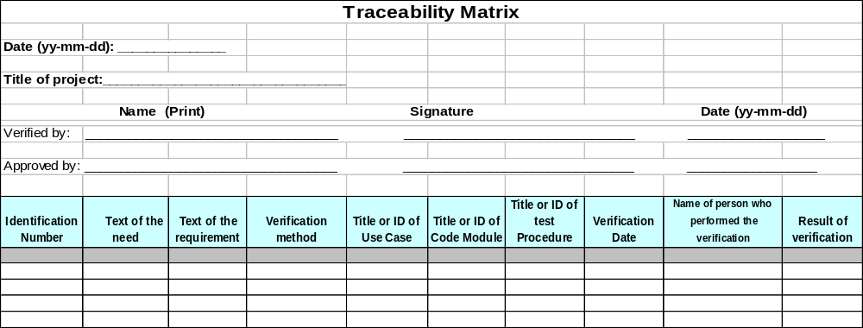

Instructions
The above table should be created in a spreadsheet or database such that it may be easily sorted by each column to achieve bi-directional traceability between columns. The unique identifiers for items should be assigned in a hierarchical outline form such that the lower level (i.e. more detailed) items can be traced to higher items.
Unique Requirement Identification (ID) | The Unique Requirement ID / System Requirement Statement where the requirement is referenced, and/or the unique identification (ID) for decomposed requirements
Requirement Description | Enter the description of the requirement (e.g., Change Request description).
Design Reference | Enter the paragraph number where the CR is referenced in the design documentation
Module / Configured Item Reference | Enter the unique identifier of the software module or configured item where the design is realized.
Release Reference | Enter the release/build version number where the requirement is fulfilled
Test Script Name/Step Number Reference | Enter the test script name/step number where the requirement is referenced (e.g., Step 1)

Guideline | Requirements traceability should:  - Ensure traceability for each level of decomposition performed on the project. In particular:  - Ensure that every lower level requirement can be traced to a higher level requirement or original source  - Ensure that every design, implementation, and test element can be traced to a requirement  - Ensure that every requirement is represented in design and implementation  - Ensure that every requirement is represented in testing/verification  - Ensure that traceability is used in conducting impact assessments of requirements changes on project plans, activities and work products  - Be maintained and updated as changes occur.  - Be consulted during the preparation of Impact Assessments for every proposed change to the project  - Be planned for, since maintaining the links/references is a labor intensive process that should be tracked/monitored and should be assigned to a project team member  - Be maintained as an electronic document

9. References to Other Standards and Models
This section provides references of this deployment package to ISO/IEC Standards and to the Capability Maturity Model IntegrationSM version 1.2 of the Software Engineering Institute (CMMI®).
Notes:
- This section is provided for information purpose only.
- Only tasks covered by this Deployment Package are listed in each table.
- The tables use the following convention:
- Full Coverage = F
- Partial Coverage = P
- No Coverage = N

Note: Coverage matrices are not completed, they are provided as an example to illustrate how to complete them.

ISO 9001 Reference Matrix

Title of the Task and Step | Coverage  F/P | Clause of ISO 9001 | Comments
Requirements identification  Step 1- Collect information about the application domain | F | 7.2.1 Determination of requirements related to the product  b) requirements not stated by the customer but necessary for specified or intended use, where known,
Requirements identification  Step 2 - Identify project’s scope | F | 7.2.1 Determination of requirements related to the product  The organization shall determine  a) requirements specified by the customer, including the requirements for delivery and post-delivery activities,

ISO/IEC 12207 Reference Matrix

Title of the Task and Step | Coverage  F/P | Clause of ISO/IEC 12207 | Comments
Requirements identification
Step 1 - Collect information about the application domain
Requirements identification  Step 2 - Identify project’s scope | P | 7.1.2 Software Requirements Analysis Process  7.1.2.2 Outcomes

CMMI Reference Matrix

Title of the Task and Step | Coverage  F/P | Objective/ Practice of CMMI V1.2 | Comments
Requirements identification  Step 1 - Collect information about the application domain | P
Requirements identification  Step 2 - Identify project’s scope | P | SG 1 Develop Customer Requirements

10. References

Key | Reference
[ISO/IEC 29110] | Software Engineering — Lifecycle Profiles for Very Small Entities (VSEs) — Part 5-1: Management and Engineering Guide - Basic VSE Profile
[OWPL-EN] | Renault A., Habra N., Alexandre S., Deprez J.-C., OWPL. Software Process Improvement for VSE, SME and low maturity enterprises. Version 1.2.2, FUNDP-CETIC, 2000.  (http://www.cetic.be/internal393.html )
[IEEE830-98] | IEEE Std 830-1998, IEEE Recommended Practice for Software Requirements Specifications, IEEE,  1998.
[ISO/IEC12119] | ISO/IEC 12119:1994 Information technology – Software packages -- Quality requirements and testing.
[ISO/IEC12207] | ISO/IEC 12207:2008 Systems and software engineering - Software life cycle processes.
[ISO/IEC24765] | ISO/IEC 24765, Systems and Software Engineering Vocabulary
[ConstSoft02] | Construx Software – Checklist for Software Requirements Specifications, 2002.
[SELB07] | Selby, P., Selby, R.W., Measurement-Driven Systems Engineering Using Six Sigma Techniques to Improve Software Defect Detection, Proceedings of 17th International Symposium, INCOSE, June 2007, San Diego.
[STAN02] | Standish Group – Chaos report 2002.
[SPEM05] | Software Process Engineering Metamodel Specification, OMG, 2005.
[VOLE07] | Volere, Requirements Resources - http://www.volere.co.uk

11. Evaluation Form

Deployment Package – Software Requirements Analysis – Version 1.2
Your feedback will allow us to improve this package, your comments and suggestions are welcomed
1. How satisfied are you with the CONTENT of this deployment package?
❑ Very Satisfied  Satisfied  Neither Satisfied nor Dissatisfied  Dissatisfied  Very Dissatisfied
2. The sequence in which the topics are discussed, are logical and easy to follow?
❑ Very Satisfied  Satisfied  Neither Satisfied nor Dissatisfied  Dissatisfied  Very Dissatisfied
3. How satisfied were you with the APPEARANCE/FORMAT of this deployment package?
❑ Very Satisfied  Satisfied  Neither Satisfied nor Dissatisfied  Dissatisfied  Very Dissatisfied
4. Have any unnecessary topics been included? (please describe)
5. What missing topic would you like to see in this package? (please describe)

- Proposed topic:
- Rationale for new topic
- Any error in this deployment package?
  - Please indicate:
      - Description of error :
      - Location of error (section #, figure #, table #) :
7. Other feedback or comments:
8. Would you recommend this Deployment package to a colleague from another VSE?

❑ Definitely  Probably  Not Sure  Probably Not  Definitely Not
Optional
- Name:
- e-mail address : __________________________________

Email this form to : simon.alexandre@cetic.be or: claude.y.laporte@etsmtl.ca or Avumex2003@yahoo.com.mx

Selby, P., Selby, R.W., Measurement-Driven Systems Engineering Using Six Sigma Techniques to Improve Software Defect Detection, Proceedings of 17th International Symposium, INCOSE, June 2007, San Diego.
www.construx.com
http://atlsysguild.com/GuildSite/Robs/Template.html
SM CMM Integration is a service mark of Carnegie Mellon University. ® Capability Maturity Model, CMMI are registered in the U.S. Patent and Trademark Office by Carnegie Mellon University.

